The Globetrotters Notes – 2/16/17

# PowerPoint Review

## Levitation

### Jake

* Rare Earth Magnetic Levitation
  + Ring of Magnets around it
  + Wall surrounding Globe
  + Magnets are $$$$
    - $100 for the magnets
  + Need at least 2 Magnets
  + Negative Exponential ration between weight and height
  + Height is 1.25 inches for 2.23 lbs
  + Cons
    - Currently Unstable
    - Expensive

### Chris

* Keep stable using Servos and Sensors
* 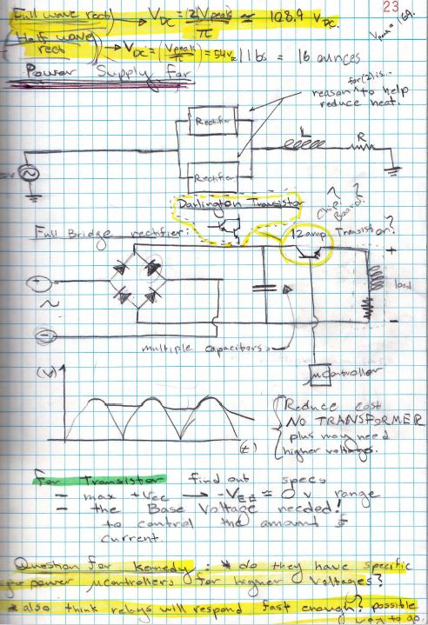
* Microcontroller Controls Current
* Requires a lot of Power if want high Levitation \

### Rence Abar

* Liquid Nitrogen
  + Utilizes Superconductors
  + Powerful and Stable
  + Cons
    - Expensive
* Stepper Motors
  + Constant Pacing, activating a different magnet
  + Idea
    - Combine idea with Chris’s Idea

## System Level Integration

### Kevin Warner

* Testing Voice Recognition and Gesture Controls with the Raspberry PI 3
  + Python Script
  + Issues:
    - Calibrating the software for Voice Command

## APIs

### Brian Pham

* Researching Wikipedia databases and Parsing the data
  + Issue involved in Parsing the data
* Drafted Python Code and pulling information

## Globe Rotation

### Andres Martinez

* OpenGL
  + Open Source
  + Render Frame constantly
* OpenCV
  + “Super Powerful” – Andres
* OpenMax
  + Media Manipulation
* Integrate with QGIS
  + Take a image of QGIS when maps is moved

## Map GUI

### Leon Tran

* Host the QGIS Map on a website.
* Interact with the map through APIs plugin
  + Through Python

## Mark

* PyQGIS
  + Interactive application with Python Scripting

# Hugh’s Review

## Globe

* Find Cheaper Alternative

## Levitation

* K&J Magnetic for Shopping Magnetic
* Chris’s Design
  + DANGEROUS because of Power Supply
  + Self-Resonate Power Supply
* Rence’s Design
  + Combo of different types of Magnets

## Projector

* Research how Projector works
* TLP
* Research more about Projectors
* Kennedy has an old Pico projector that we can use
* Convex Mirrors
  + Light
  + “Dirt Cheaper”
  + Front silver mirror
* Fisheye Lens
  + Cons
    - Expensive

## Input Systems

* **Mongol DB** that we can use for a database
* We can base it from Amazon Echo or fire stick
  + Richard says it is available
* Speech to Texts
  + Longest Delay is 3 seconds
  + Python need to use multiple threads to get a more streamline process

## Projection

* Hugh Likes Andres Recommendation
* Video Rendering of movement of globe
  + Store Images

## QGIS (Mapping)

* Store the map and all the info locally
* Play with QGIS plugins to control map

## Microcontroller

* Don’t use PIC 12 or 16
* DSPIC 33 & PIC 24E are good
  + 16 bit
* PIC 32
  + 32 bit